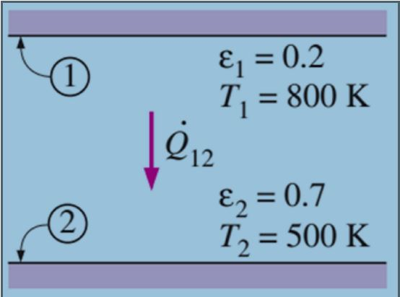 $\dot{Q}= 5.67×{10}^{-8}\frac{{800}^{4}-{500}^{4}}{\frac{1}{0.2}+\frac{1}{0.7}-1}=3625.4\frac{W}{m^{2}}$

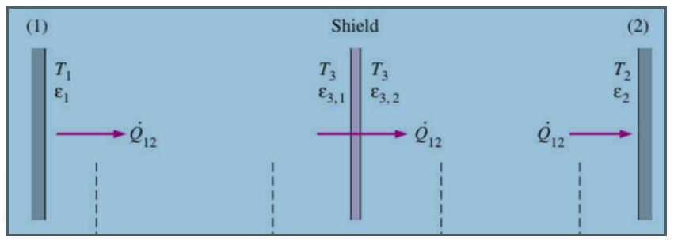

How many shields with epsilon=0.1 we should add in order to have our heat transfer rate to be 1 percent of the case without shields?

3625.4\*(1/100)=36.25

Q/A= (5.67\*10-8 (8004 – 5004 ))/((1/0.2)+(1/0.7)+n((1/0.1)+(1/0.1)-1)=36.25

n=28.1 🡺 28 shields needed to make the radiative heat transfer to 1 percent

1st step:

In sketch up we create plan of the offices

2nd step

Then choose the whole plan and select the create spaces from toolbar

Floor height is 10’ and 3 floors. We can also see the details from information tool from the toolbar.

3rd step

Now we define which walls are interior and which ones are out with matching surface

4th step

Then we can add the windows with the extensions tab, ratio is 70 percent and windows will be shown on the model

5th step

We can create shadings using surface selection and to not choose the north since it does not need shading we select all facades and choose from 45 to 270 degrees.

6th step

Now we add the overhangs to the selected facades with use of the extension named external shadings

7th step

Now we choose the spaces define thermal zones with use of of the side bar and save our project in the toolbar for open studio since we do not need sketch up anymore.

8th step

We go out of sketch up and open the file we just created from open studio

And add the weather for the city our project is in.

9th step

We run the file and will have our results in tab for it